**Project 01_06_03**

The Capstone assignment that you coded for the second and final semester of your first year should now be extended to incorporate new technology you have learned in C-201. This project will require you to continue to work as a team. However, this part will be totally concentrated on the coding aspects of the project.

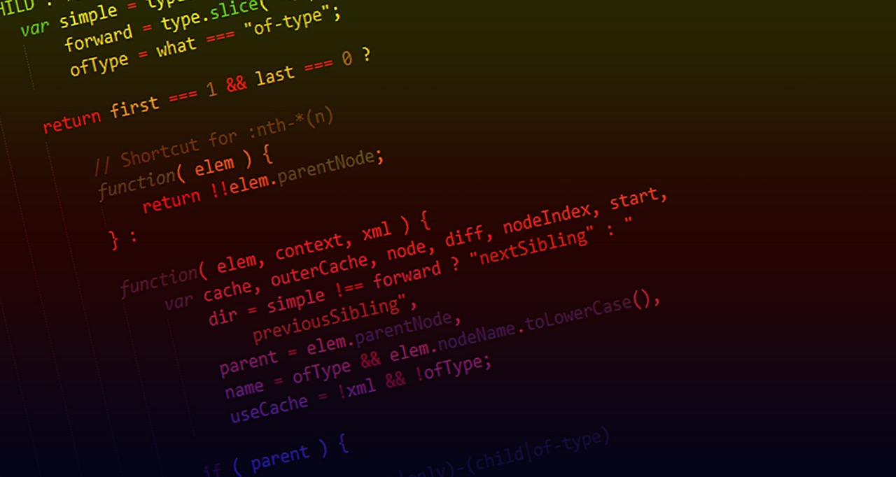 

Your website, by the end of this phase, will consist of HTML, CSS and JavaScript. You may have used Bootstrap and JQuery, but this part of the project requires original hand coding in JavaScript.

The following HTML pages must be included:

1. Index (Home)
2. About
3. Products
4. Web Form (Contact, Order, or any other pre-approved Web form)

As previously, you should already have included, at a minimum, one CSS stylesheet. This stylesheet must consist of NO LESS than 25 unique style rules.

You must use all of the following JavaScript concepts in your website:

* Functions
* Event handlers
* Objects and methods
* Time-delayed and time-interval commands
* Arrays - at least one
* Your Web form field sets (for each student) must include:
  + Regular input fields
  + Check boxes
  + Radio buttons
  + Select lists
  + Textarea control
  + Number fields
* Complete validation of all fields, including required and not required, with user friendly messages and graphics.
* Form submission that produces a web page showing the data from the form, which will only execute if the form is completely valid.

**This will be your rubric for the code of your website:**

